

DLD Lab-10

7-Segment Display



NATIONAL UNIVERSTIY OF COMPUTER AND EMERGING SCIENCES, FAST- Peshawar Campus

Department Of Computer Science

Instructor: Engr. Waseem Ullah

EL1005 – Digital Logic Design-Lab

SEMESTER SPRING 2022

Contents

1. Objectives: 2

2. Outcomes: 2

3. Equipment Required: 2

4. Seven Segment LED Display: 2

5. Two types of 7 Segment Displays 3

6. Working of 7-Segment Display (LED & LCD) Circuit 6

7. 7-Segment Truth Table 11

8. 7-Segment Display Decoder Circuit 15

9. Application of BCD to Display Decoder 15

10. IC-74LS47 Implementation 16

# Objectives:

Familiarization with operation of 7-segment display

Interfacing with BCD to Seven Segment Code converter IC

Design of BCD to 7-segment code converter circuit

# Outcomes:

Students should be able to

Interface a 7 segment display with BCD to 7 segment code converter IC

Design and implement the BCD to 7 segment code converter using Kmaps

# Equipment Required:

* DEV-2765E Trainer Board / Multisim 14.2 /Logic.ly
* 7448 BCD to 7-segment code converter
* Common-cathode 7-segment LED (single and double digit) Display

# Seven Segment LED Display:

Decimal digits from 0 to 9 can be shown using a 7–segment LED display unit. This unit shows one decimal digit using 7 LED segments to form the numbers from 0 to 9. These 7-segments are a, b, c, d, e, f, g

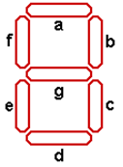

7-Segment Display

A BCD-to-seven-segment decoder (7448) is a combinational circuit that converts a decimal digit in BCD to an appropriate code for the selection of segments in an indicator used to display the decimal digit in a familiar form. The seven outputs of the decoder (a, b, c, d, e, f, g) select the corresponding segments in the display, as shown in Fig.(a) . The numeric display chosen to represent the decimal digit is shown in Fig.(b) .

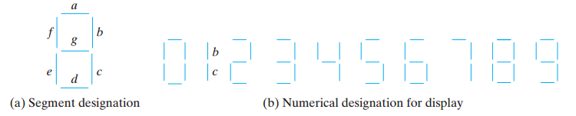

# Two types of 7 Segment Displays

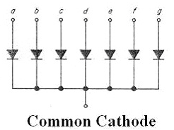 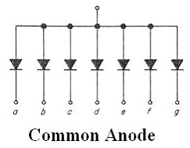

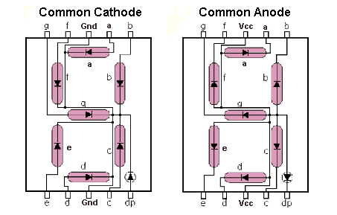

**Different decoder IC with different display**

7447 (BCD to 7-segment Converter ) outputs are active low , it is used with common anode display .

7448 (BCD to 7-segment Converter ) outputs are active high , it is used with common cathode display .

**Pin configuration**

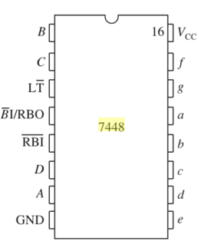

7448-IC Pin Configuration

The pin connections of the common-cathode 7-segment single digit display are below:

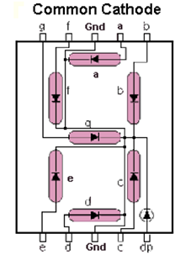

**Procedure**

1. Connect the trainer with the power supply
2. Mount the BCD to 7-segment driver IC 74LS48 on the trainer board
3. Connect pins of the IC according to the diagram
4. Connect pin 16 to +5 V (Power Supply) and pin 8 to GND (Ground).
5. Apply all combinations of inputs leaving pins 3,4,5 unconnected and see the corresponding decimal digit on the 7-segment LED display .Show these to the instructor

**Design of BCD to seven segment code converter**

Using truth tables and Karnaugh maps, design the BCD-to-seven-segment decoder using minimum number of gates.



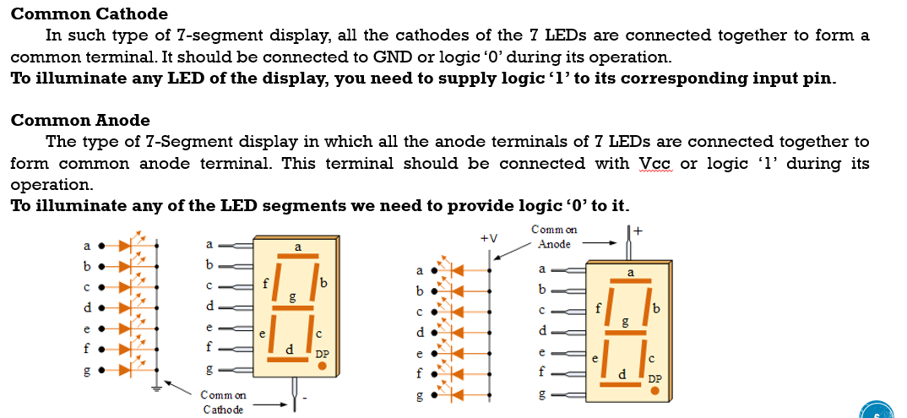



# Working of 7-Segment Display (LED & LCD) Circuit

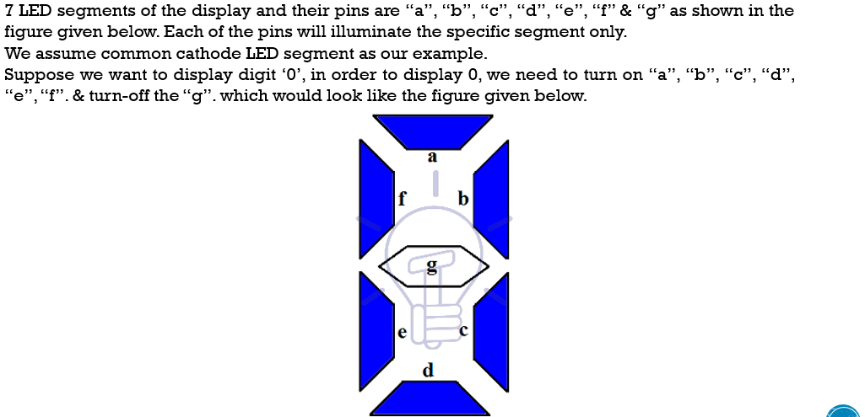

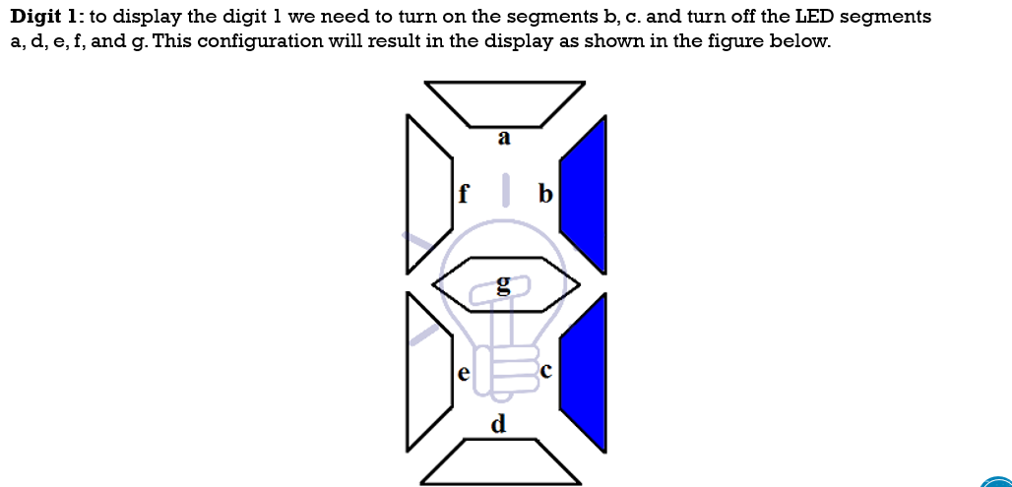

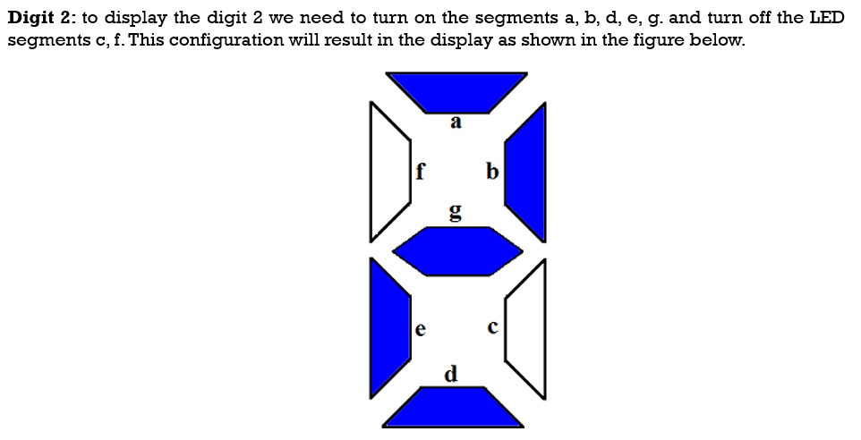

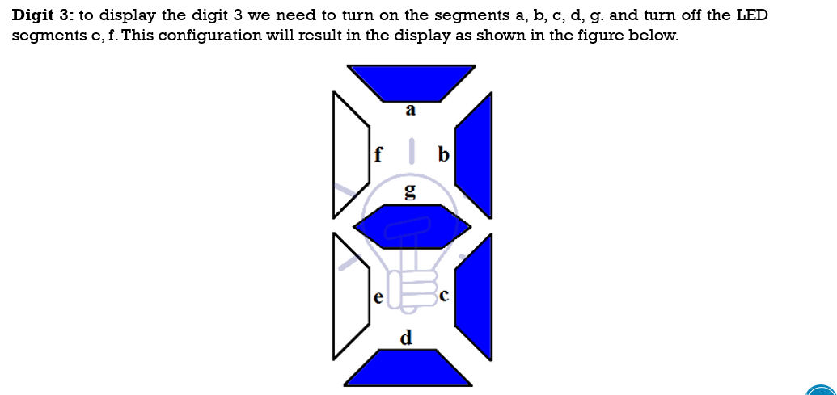

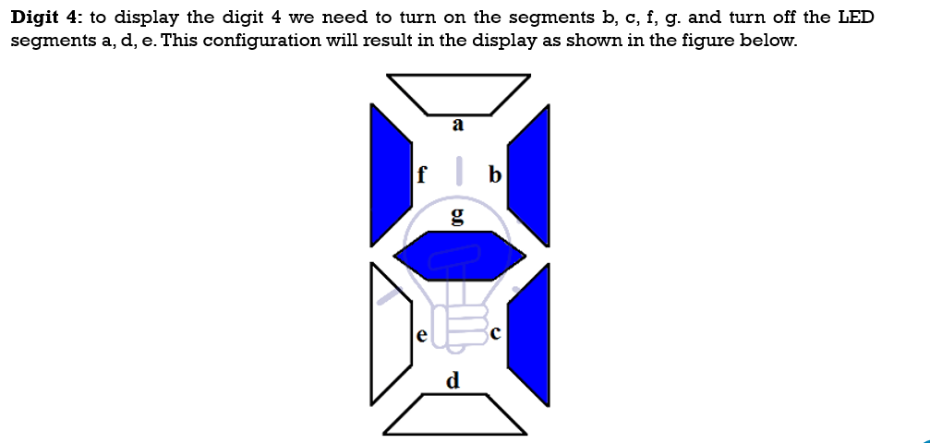

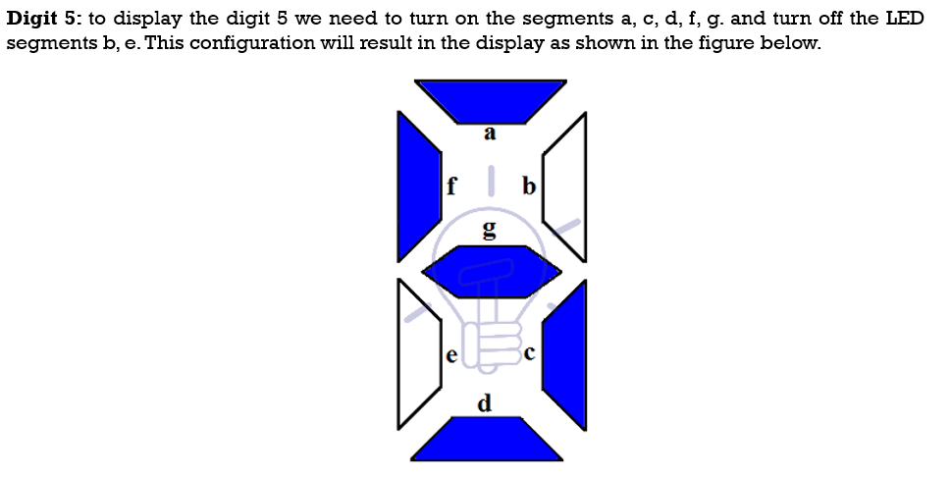

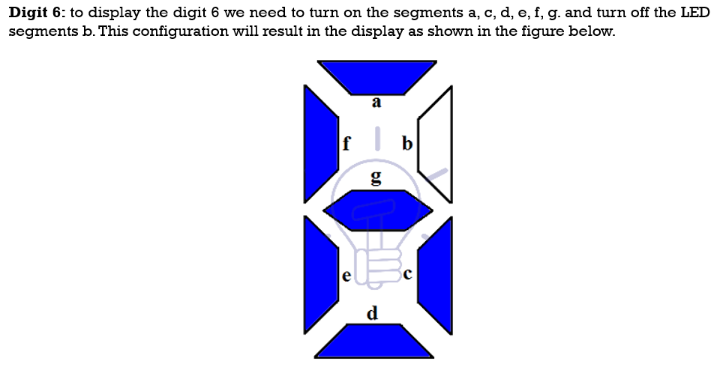

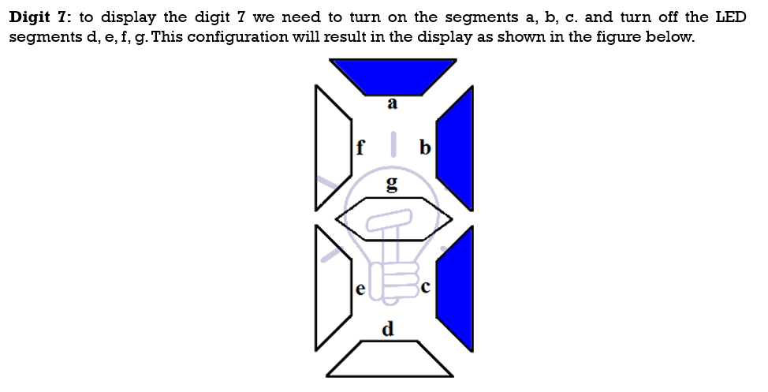

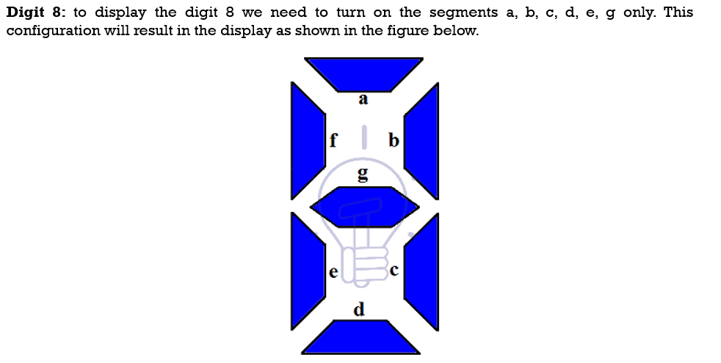

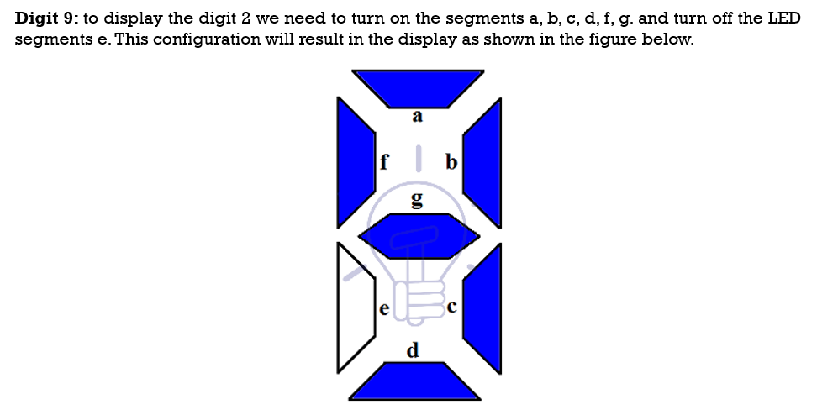

# 7-Segment Truth Table

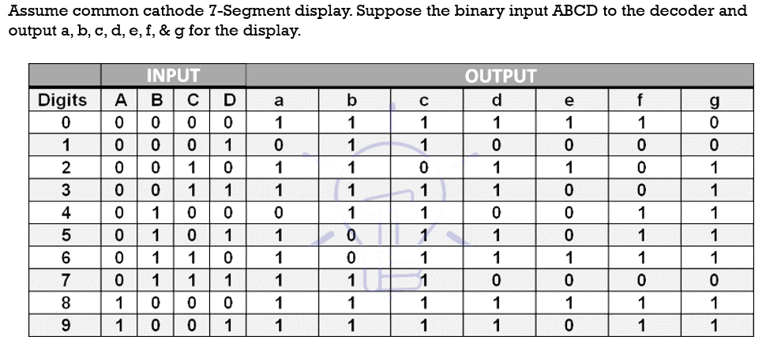

**for output a:**

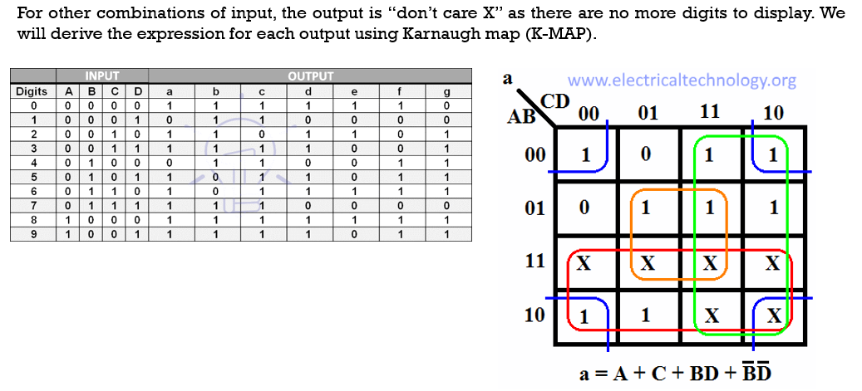**for output b:**

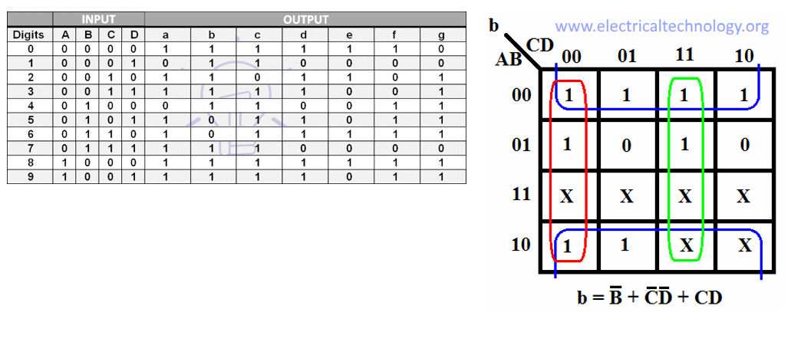**for output b:**

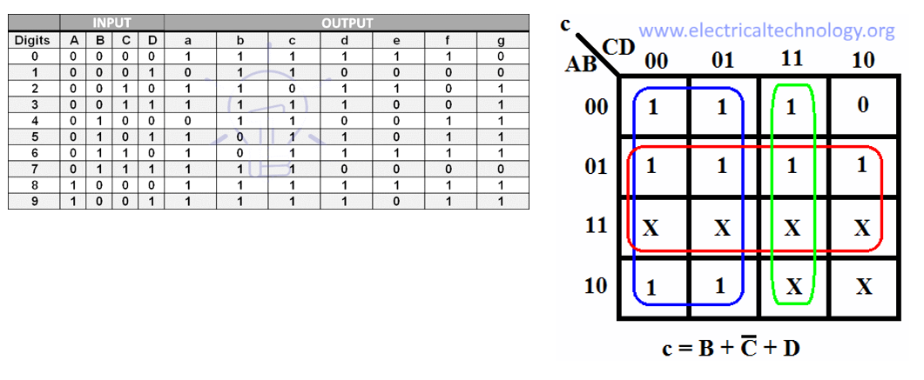**for output c:**

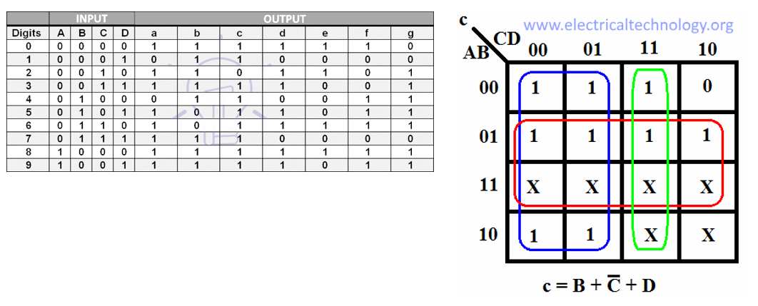**for output d:**

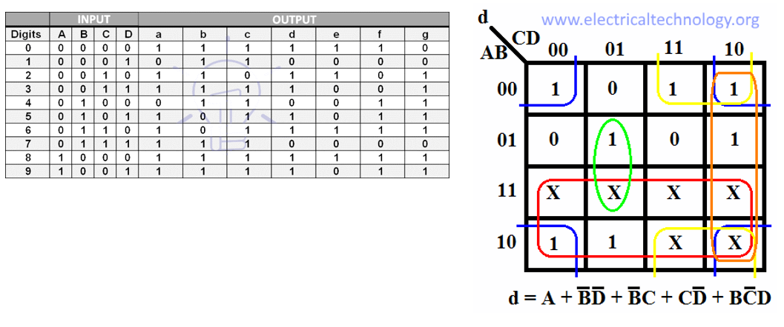

**for output e:**

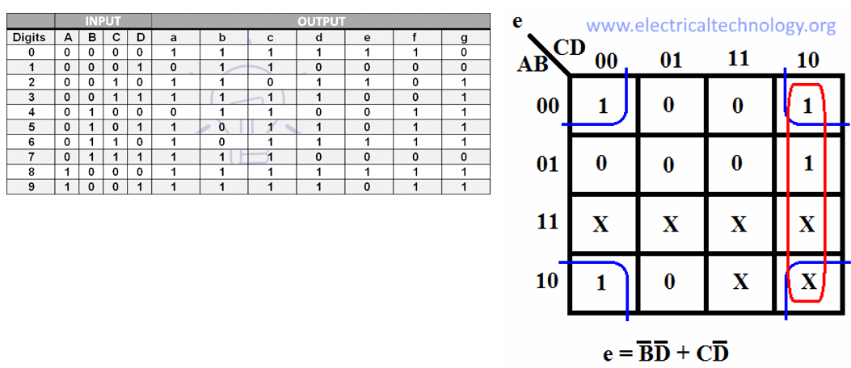

**for output f**

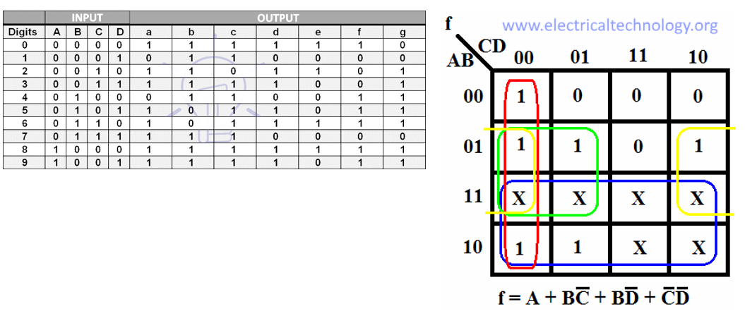

**for output g**

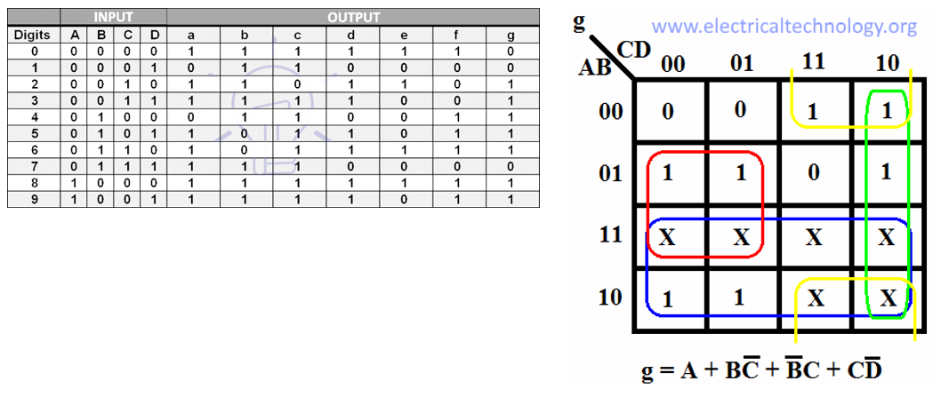

# 7-Segment Display Decoder Circuit

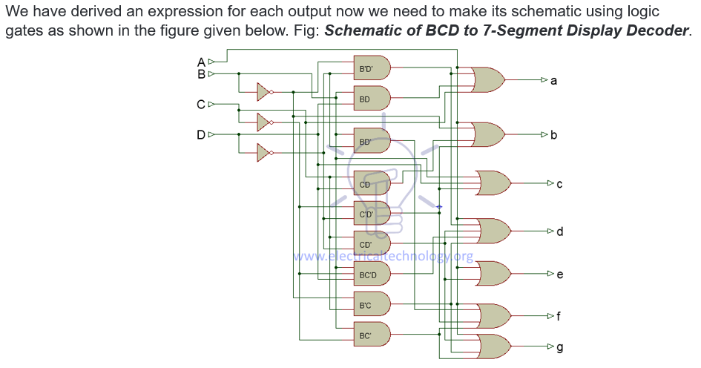

# Application of BCD to Display Decoder

* This circuit can be used as a timer circuit.
* With little modification, it can be also used to display the number clock pulses.
* It can also be used with modification to display alphabet display system instead of decimal display system.
* 7-Segment display are mostly used in digital clocks, electronic meters, odometers as well as LCD application due to low current consumption.
* They are also used in various measuring instruments, digital watches and digital counter

# IC-74LS47 Implementation in Multisim

